NON INVASIVE HEARING AID USING THE NATURAL AMPLIFICATION

OF EAR THROUGH BONE CONDUCTION

V.Sundaram, P.V.Swamynathan, A.Kishore Kumar, Ajith Chandran.K, M.B.Nisanth

*Abstract* --Several hearing aids have been invented for outer ear drum problems whereas inner ear drum problem is permanent and it can be fixed only by surgical means. This hearing aid is designed to use the natural amplification of ear .This device consists of a PIC controller, a GSM module, a playback module and a relay. Any signal that is received by the GSM module is transmitted to the piezoelectric actuator by the PIC controller which generates the vibrations that is sent to cochlea through the teeth .This way the sound is imported from the impaired ear to hearing ear. This device can be fixed on the teeth and no alteration of the teeth is required .It is completely non-invasive. The GSM module receives incoming calls and automatically answers the calls via AT commands. The playback module allows the user to hear music and receive the incoming calls giving priority to calls. A relay is used to switch between the music playback and GSM module. It is simple, removable and customizable according to the users will.

Index terms -- Bone conduction, AVR Controller, GSM modem, Soundbite sensor, Playback module.

1. INTRODUCTION

Communication is a major part of life. But deaf people are restricted from the normal form of communication and deafness is third most common disability in the world. This can be rectified by using various medical surgical treatments which are quite costlier. The human auditory system consists of outer, middle and inner ear. The eardrum converts the sound waves which are actually the vibrations in the air to different vibrations and transmits into cochlea which is connected to the auditory nerve system. Sometimes the sound waves directly goes into inner ear bypassing the eardrum, this happens through bone conduction. This is one of the way to hear our own voice. Whales hear through bone conduction.

In 18th century a famous composer Ludwig van Beethoven, discovered Bone Conduction, he was completely deaf. To listen to the sound of piano with the help his jaws, Beethoven attached a rod to the piano and clenched the rod in his teeth as vibrations were transferred from the piano to his jaw He received perception of the sound or vibrations. This proved that sound could reach our auditory system or the inner ear through another medium.

1. LITERATURE SURVEY

The paper addresses the inner ear drum hearing losses which does not rectify the hearing loss but amplifies the sound or making it louder so that it reaches the inner ear. Problems like abnormal spectral and temporal processing are complex and cannot be solved by amplification, hence it can be solved by bone conduction. The paper also presents the bone conduction devices that enables people with impaired hearing to gain the ability to hear without the usage of their ear drums. They also specified different bone conduction devices based on different properties.

1. BONE CONDUCTION

Bone conduction devices are used to transfer the sound vibration through the bones rather than air conduction through ear drums. Based upon the principle of conduction these bone conduction devices are classified into three major categories and they are

(1) Skin Drive BCD’s

(2) Direct Drive BCD’s

(3) In-Mouth BCD’s.

* SKIN DRIVE BCS’S

These devices are based on the fact that sound vibrations are passed on with help of skin which must not be damaged. These can be further divided into conventional skin drive BCDs which has most of the components outside the ear and the passive transcutaneous skin drive BCDs which have magnets inserted or fixed in a person’s body.

* DIRECT DRIVE BCD’S

This type of devices, the sound vibration is directly transmitted to skull bones with help of a screw or through a skin penetrating support. Major advantage of this is transmission is not damped by soft tissues. BCDs can be further divided into 2 types of devices percutaneous and active transcutaneous devices ,a BAHA is said to be a passive device on the other hand a device with transducer embedded under the skin is said to be an active device.

* IN –MOUTH BCD’S

In these types of devices sound via the teeth is transmitted to the skull bone, these sound vibrations are created by a piezoelectric transducer. The vibrations is wirelessly transmitted to transducer inside mouth and

vibrations are sent to upper back teething then transmitted to the inner ear (cochlea) via the skull bone also there is a microphone at the back of the deaf ear. This can only be used for single sided deafness. A device called Sound-Bite by Sonitus Medicl.

1. COMPONENTS

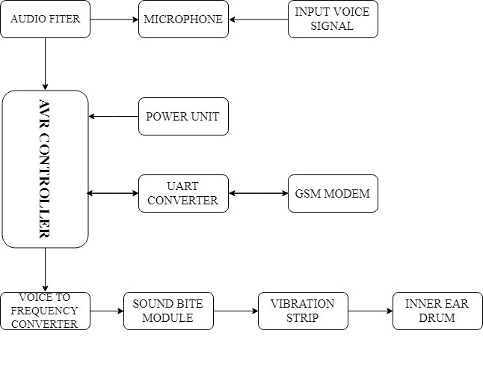

1. AVR CONTROLLER

This AVR microcontroller has been used in many applications, mainly in prototyping of a project. This is an 32bit Reduced Instruction Set Computing (RISC) and it has SRAM, on-chip programmable flash memory, IO data space, and the EEPROM.

These controllers are available in there categories,

* Tiny AVR
* Mega AVR
* Xmega AVR

1. Tiny AVR

This AVR is used only for simple applications such that it has a less memory varying from 0.5 to 8KB and also it is small in size

1. Mega AVR

Mega AVR is one of the microcontroller which having a good memory of upto 256KB. It can be used with many high-end applications because of the higher number of inbuilt peripherals.

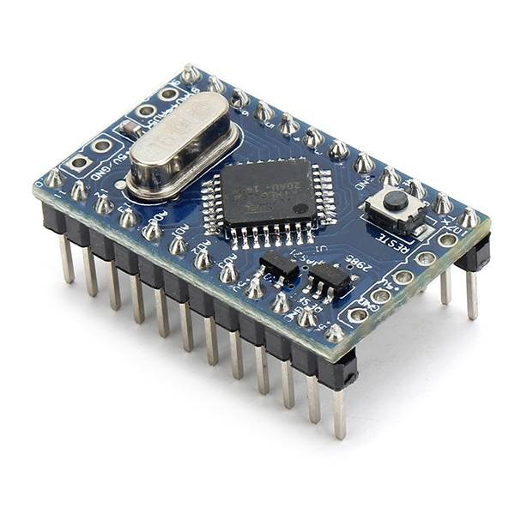

1. Xmega AVR

It is the microcontroller which needs maximum memory for storing programs because it has been used for compound applications. When comparing with all the other AVR’s it has the maximum speed.

|  |  |  |  |
| --- | --- | --- | --- |
| AVR | PINS | MEMORY | FEATURES |
| TINY AVR | 6-32 | 0.5-8KB | SMALL IN SIZE |
| MEGA AVR | 6-32 | 4-256KB | EXTENDED PERIPHERALS |
| XMEGA AVR | 44-100 | 16-384KB | DMA |

1. GSM MODULE

GSM module is a mobile communication module. It stands for global system for mobile communication. Data services and mobile voice can be sent over/ transmitted over an open channel with the help of the GSM. It operates over frequency bands 800-1900 MHz. GSM uses TDMA (Time Division Multiple Access) for the communication procedure. Can even transmit at the speed of 120mbps.The module can be chips can use macro, micro, pico and umbrella cells for architectural purposes. Each cell varies based on the principles. It also specifies the methodology to improve the existing bone conduction devices by improving the speech intelligibility with the help of super direction beam former implementation domain. TDMA is the process by which each user is allotted with/over the same frequency band for the purpose of transmission of the data respectively. And the features of GSM are (1) Improved spectrum efficiency,(2) Improved spectrum efficiency, (3) International roaming, (4) Compatibility with integrated services digital network (ISDN),(5) Support for new services, (6) SIM phonebook management, (7) Fixed dialing number (FDN),Real time clock with alarm management, (9) High-quality speech, (10) Uses encryption to make phone calls more secure, (11) Short message service (SMS).

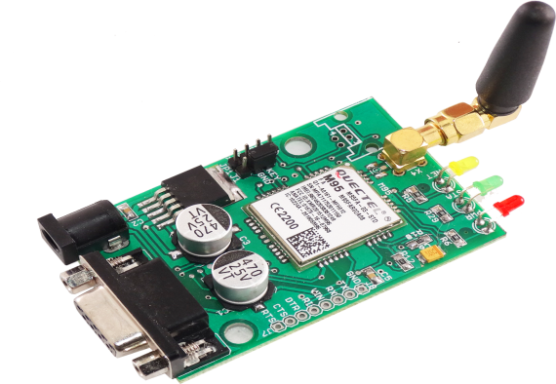

1. PLAYBACK MODULE

This is a single chip, high quality voice recording and playback module .WTV 040 can be operated using 3.3V or 5V microcontrollers directly. It has a inbuilt Digital to Analog converter (DAC) and Analog to Digital converter (ADC). It is non-volatile and it uses flash memory, so no backup of battery is needed. It can record voice with any on board microphone or ant audio input. Also voice record upto 20 minutes and it is done at 4-8 kHz sample rate.

1. RELAY SYSTEM

A relay is an electromechanical switch which is powered by electric current. A single relay board arrangement contains driver circuit, power supply circuit and isolation circuit. Relay is assembled with the circuit and the driver contains transistors for switching operations. An isolation circuit prevents reverse voltage from the relay which protects the controller and the transistor from damage. The input pulse for switching the transistor is given from the microcontroller.

1. SOFTWARE

In our proposed system, we have used ATMEL Studio 6.2. This is complete software suite from Atmel, it is an integrated development Environment that allows you to write C/C++ programs, complies with a free AVRGCC compiler and produces hex files. It is a proprietary freeware integrated development environment for the development of embedded applications on AVR microcontrollers.

1. SOUND BITE SENSOR

Sound bite sensor is a non-surgical bone conduction [prosthetic](https://en.wikipedia.org/wiki/Prosthesis) device that transmits sound via the teeth. It is an alternative to surgical [bone conduction](https://en.wikipedia.org/wiki/Bone_conduction)  devices, which require surgical implantation into the skull to conduct sound. Conventional hearing aid which a amplify sound can cause distortion for the patient .Sound waves travel through the medium(Bones)and reaches the inner ear through this device .It processes sound waves and wirelessly transmits the sound vibrations which can be picked up by the cochlea.

1. WORKING

This hearing device is designed to use the natural amplification of your ear. Any sound that is coming from GSM Modem. It uses a digital processor (PIC16F877A) to transmit to the sound to a piezoelectric actuator which needs very little power to generate the vibrations that travel through bone, which in turn sends those sound vibrations into your cochlea through your teeth. This way, thesound is transported from your impaired

ear directly to your hearing ear. The hearing device will be fitted to the upper left or right teeth in the back of your mouth. This doesn’t require any of your teeth to be altered, and the device can beinserted and removed easily. This hearing device is a flat piece(in Real-Time Product) that contains a sealed rechargeable battery, and electronics and wireless capabilities that can pick up sound transmissions from the behind-the-ear microphone

.

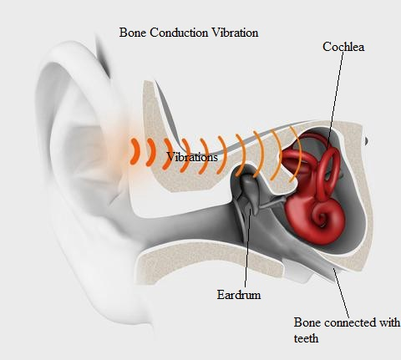

1. CONCLUSION

Through the efficient usage of this system, it is possible to rectify and reduce the world’s third most common disability (deafness) without any implantable surgeries which are also costlier and might have side effects .Our proposed system is cost efficient, risk free , and less maintenance .This will help the deaf people to get back their lost ability through simple process. This system will attain great heights because of the fast evolving technology.

1. FUTURE SCOPE

Since it is wired module, in future it can be developed as a wireless module .It can be made more compact so that it can be carried in pocket like a mobile phone. Also we can integrate this system in mobile phones so that deaf people can enjoy all the features in the mobile phone and no need of carrying the hearing aid as an additional gadget.

1. REFERENCE
2. Yash Gupta & Praveen Kumar, Amity University “Bone Conduction Auxiliary and Tactics for Man machine Interface for Hearing Impaired Users” ICACCE 2018
3. Liu CC, David Livingstone, Warren Yunker. “The role of bone conduction hearing aid in congenital hearing loss: A review.” Journal of Pediatric Otorhinolaryngology,1Jan 5, 2017.
4. AfterShokz, Retrieved January 26, 2017, from Vincent, J. (2016, October 24). “Are bone conduction headphones good enough yet?”
5. A.S.Bregman, Auditory scene analysis: The perceptual organization of sound. MIT press, 1994. “A comparison of auditory perception in hearing-impaired and normal-hearing listeners: an auditory scene analysis study,” Iranian Red Crescent
6. Medical Journal, vol. 15, no. 11, 2013.
7. Wazen JJ and Van Ess MJ, Hearing Aids and Devices Including wearable Bone anchored and semi implantable.
8. N. Shigekawa and M. Mori, “A study on a user interface using bone transmitted sounds,” in 2013 Autumn Meeting of The Acoustical Society of Japan, 2-5-5.
9. T. Fujimoto and M. Mori, “Word intelligibility of bone conductive

sound when wearing ear plugs,” in 2015 IEEE 4th Global Conf. on Consumer Electronics (GCCE) ,Osaka.

1. Zhu Xiaofeng. Bone-conduction technology and application in information communication. The Ministry of information industry, 2008.
2. Nasim Shams, Behnaz Ghoraani and Sridhar Krishnan. Audio Feature Clustering for Hearing Aid Systems 2009.